

Sleep Problems in Infants and Toddlers
Ever since my first son was born, I have maintained that “sleep is the currency of parenthood.” It doesn’t really matter what type of home you live in or what kind of car you drive. If your child sleeps well, you are rich; if they keep you up, you are poor. My goal is to help the parents of my patients achieve prosperity as parents both in infancy and beyond.
Different Types of Sleepers:
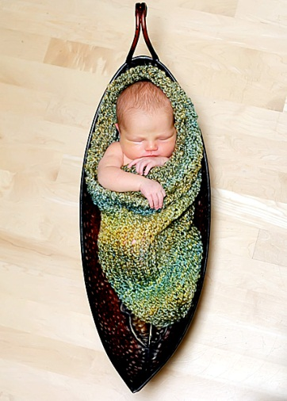
In my experience, there are three different types of sleepers. The first category is comprised of babies who, if you do everything “by the book,” will get in a decent sleep routine. This works well until either they get sick and are up at night or you travel somewhere and disrupt the environment. When this happens, the established order of sleep will get ‘out of whack’ until you re-establish the rules and routine. Most babies fit into this category.
The second category is comprised of infants who will sleep all night long without problems no matter what the situation or circumstances. These kids are a dream and for obvious reasons it is best if they come along later in the birth order so a parent doesn’t get spoiled into thinking that all babies are this easy. About 10 percent of infants are born like this. It is how they come out and, wish as you may, there is nothing that I know of that you can do to create this child.
The third category, are infants that despite your best efforts to be consistent and stick to a plan, will still be up a few times a night, every night—needing to nurse or just be helped back to sleep. Even though it doesn’t seem to help the situation much, it is important to stick to a structured plan. Long term, these kids will eventually sleep. It is much easier to continue good habits then break bad ones. Since you won’t know exactly when this third category of baby is ready to sleep all night, you need to have the right routines and patterns set up for them so they can show you when they are ready.

The Basic Pattern of Sleep:
Infants, children and adults share some common characteristics of sleep. In general, the first 4 hours of sleep is composed of ‘delta’ sleep where the brain is in a deep, restful slumber and is difficult to wake. This is the kind of sleep where if the phone wakes you up an hour after going to sleep, it is difficult to speak or have a coherent conversation. During this phase, the brain is not dreaming and the body will breathe in slow steady, deep breaths.
After this initial 4 hour stretch, people then progress from deep to light sleep in a cycle that is about 90 minutes long. During each cycle, we might wake up briefly, look at the alarm clock, roll over and go back to sleep. On some nights, an individual might not remember waking up and repositioning themselves, whereas on other nights we might lie awake for a while, reviewing the day or worrying about something. Whether we remember these nighttime wakings or not, infants, children and adults all follow this pattern. With only minimal variation, it is fairly consistent.

Sleep Associations:
The other thing that infants, children, and adults share is the development of sleep associations. Sleep associations are conditions under which we have trained our body to fall asleep. For most adults, our pre-sleep routine consists of brushing our teeth, washing our face, and putting on pajamas or a night gown. Then, most of us get into bed with a pillow under our head and a blanket over our body. Those are the conditions under which we have trained ourselves to fall asleep.
What would happen if you awoke for one of your normal “wakings” and your pillow had fallen on the floor? You would have to pick it up put it back under your head. If you didn’t, it would be hard to fall asleep! What if you developed some kind of back pain, and your doctor told you to not sleep with a pillow anymore? It might take you a few nights or a week to get used to it, but you would adapt and learn to sleep without it. You can change your sleep associations if you need to. It just takes a little time to establish new ones.
The vast majority of sleep problems stems from problems with faulty sleep associations. Once you have identified the maladaptive association, then the solution to the problem is to change it. Sleep is something that children do for nearly half of their lives. A well-rested child is happier, less prone to illness, and more able to develop and learn. A well-rested parent (not an oxymoron) will have more patience with their child and will enjoy the process of parenting much more.

Troubleshooting:
So consider the scenario of a 7 month-old infant whose mother brings him in to see me because he wakes up several times a night needing to nurse. The baby goes to sleep at 8pm and sleeps well until midnight when he wakes up crying. Mom feeds the child, but only briefly, and he falls back to sleep until 1:30 am when he wakes up crying, unable to sleep again until he is fed again. This happens again at 3am and 4:30am and 6:00am. By 7am the baby is up for the day. But mom is exhausted since she had to wake up to feed the baby 5 times in the night. This pattern has gone on like this for 3 months—an initial 4-hour stretch of good sleep followed by waking every 90 minutes requiring a brief feeding to fall back to sleep.
The problem with this baby’s sleep is NOT that he is waking up. That is normal and completely predictable. The problem is with the sleep association. This baby’s “pillow” is his mom feeding him to sleep. The solution is to get him to fall asleep under the same conditions that will be present WHEN (not if) he wakes during the night. Doing this means changing the bedtime routine.

This 7 month-old is pre-verbal, so mom can’t sit the baby down and have a discussion with him about how they are going to be changing the way he is put to sleep. Nursing to sleep is what has been the norm his whole life and when that is suddenly changed, he is going to have to learn how to put himself to sleep under new circumstances—without his “pillow.” The process involves, getting him ready for bed and nursing him as usual. Before he falls asleep, the mom stops the feeding, burps him and puts him in the crib. He will cry. He is a baby and that is all that he can do. What he would say if he could talk is “Hey Mom, every night you put me to sleep by nursing me and tonight you didn’t! What’s up with that?” And the mom and dad can say, “It’s OK love, you need to learn to put yourself to sleep. You are old enough and I know you can do it. I’ll visit you every so often until you fall asleep so you know that I’m there for you. Good night!” Then the parent can visit in incrementally longer times until the baby learns to soothe himself to sleep.
Most babies can do this by 4 months of age. At 4 months it only takes a few nights to learn. At 6 months and beyond, it can take longer because they’ve grown accustomed to the sleep association for longer. Be patient, they’ll get it and then everybody will sleep better.
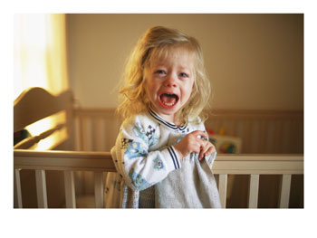
Toddlers are more stubborn. The maladaptive sleep association has often gone on for longer and they usually have the ability to cry for longer than most people can stand it. In this situation, I usually recommend a kinder and gentler approach to accomplish the same end.
The first step is to get the child sleeping in their own bed or crib (if they aren’t already.) If the child is used to falling asleep in the parent’s arms, in the parent’s bed, or on the couch this will probably be the hardest step. Develop a bedtime routine: a bath, put on P.J.s read “Goodnight Moon”, etc. Then put the child into their crib and do whatever it takes to help them fall asleep without picking them up. You can rub their backs, sit in a rocking chair next to the crib and reach through the slats, sing softly until they fall asleep. When (not if) they wake up go right back to what you did to help them fall asleep that night. This might require the parents to get up a bit at night but since the child has a maladaptive sleep association, this has already been the case—just in a different location.
Once the child is able to fall asleep in their own crib/bed for a few days, then begins the gradual process of extricating the parent from the sleep association. For the next few nights, rub the child’s back for a shorter time, sing a bit softer, until you can get your child to fall asleep in their bed with you sitting there but not touching them. Then over the next 7-10 days, gradually move your position a bit farther from their bed every few nights so that eventually, you are in the doorway, then the hall, then away from them completely. Remember that when the child wakes up at night, you need to go back to the position you were in at bedtime.
I know that this process seems rather convoluted. It will require, on average, about 2 weeks of commitment and consistency from the parenting “team.” But if you stick with it, you will be left with a child who can settle themselves to sleep and parents who have taken their nights back.
Of course every child and every situation is a little bit different, so you may need to be creative and tweak what I’ve outlined here. In most cases however, the problem and the solution follow a fairly predictable theme. A child’s sleep association that requires the parent’s presence will interrupt the parent’s sleep throughout the night. Extracting yourselves from your child’s sleep is probably one of the greatest gifts you can give them—and yourselves.
If you have difficulty troubleshooting sleep problems, I strongly recommend reading Solve Your Child’s Sleep Problems by Richard Ferber, M.D. There have been many books written regarding infant and children sleep. Dr. Ferber is the one who actually did most of the research on which these books are based. I think his book explains the why’s and how’s of sleep very well and should be a resource in every home.
Feel free to bring up troubles you’re having and any concerns during appointments or call to discuss things. One of the most rewarding things in my job is hearing back from sleep deprived parents about how their child who used to keep them up all night is now sleeping all night uninterrupted.
I wish you all riches and prosperity in dreamland!
--Be Well

Drew Nash, M.D.

